EXPERIMENT NO.-1

Network Commands on Linux / Unix

Some basic commands

C:\Documents and Settings\student>ipconfig
Windows IP Configuration
Ethernet adapter Local Area Connection:

Connection-specific DNS Suffix . :
IP Address. . . . . . . . . . . . : 192.168.1.11
Subnet Mask . . . . . . . . . . . : 255.255.255.0
Default Gateway . . . . . . . . . :

C:\Documents and Settings\student>hostname
FUNCTION- The hostname command is used to show or set a computer's host name and domain name i.e. displays system identity name. It is one of the most basic of the network administrative utilities.
OUTPUT
E1-CSLAB8-12

C:\Documents and Settings\student>ping 192.168.1.12
FUNCTION- The PING command is used to test the connection and latency between two network connections. These connections can be either in a local area network or a wide area network or the internet as a whole. The PING command sends packets of information to a specified IP Address and then measures the time it takes to get a response from the specified computer or device.
OUTPUT
Pinging 192.168.1.12 with 32 bytes of data:

Reply from 192.168.1.12: bytes=32 time<1ms TTL=128
Reply from 192.168.1.12: bytes=32 time<1ms TTL=128
Reply from 192.168.1.12: bytes=32 time<1ms TTL=128
Reply from 192.168.1.12: bytes=32 time<1ms TTL=128

Ping statistics for 192.168.1.12:
Packets: Sent = 4, Received = 4, Lost = 0 (0% loss),
Approximate round trip times in milli-seconds:
Minimum = 0ms, Maximum = 0ms, Average = 0ms

C:\Documents and Settings\student>tracert 192.168.1.12
FUNCTION- Traceroute, also called tracepath, tracert or trace route, is a network tool used to determine the "path" packets take from one IP address to another. It provides the hostname, IP address, and the response time to a ping. Our visual traceroute also includes a map displaying each of the hops.
OUTPUT
Tracing route to 192.168.1.12 over a maximum of 30 hops
1 <1 ms <1 ms <1 ms 192.168.1.12
Trace complete.

C:\Documents and Settings\student>pathping 192.168.1.12
FUNCTION- It combines the functionality of Ping with that of Traceroute, by providing details of the path between two hosts and Ping-like statistics for each node in the path based on samples taken over a time period, depending on how many nodes are between the start and end host.
OUTPUT
Tracing route to 192.168.1.12 over a maximum of 30 hops
0 192.168.1.11
1 192.168.1.12

Computing statistics for 25 seconds...
Source to Here This Node/Link
Hop RTT Lost/Sent = Pct Lost/Sent = Pct Address
0 192.168.1.11
0/ 100 = 0% |
1 0ms 0/ 100 = 0% 0/ 100 = 0% 192.168.1.12

Trace complete.

C:\Documents and Settings\student>arp -a
FUNCTION- ARP is used to perform IP address resolution which is the linking of IP addresses to MAC (Media Access Control) hardware addresses. ARP uses a broadcast to do this by asking the host that has the given IP address to respond to the broadcast with its MAC address.
OUTPUT
Interface: 192.168.1.11 --- 0x2
Internet Address Physical Address Type
192.168.1.12 00-16-e6-1a-aa-df dynamic
192.168.1.131 00-16-e6-19-c4-27 dynamic

C:\Documents and Settings\student>netstat 192.168.1.12
FUNCTION- It is a command-line tool that displays network connections (both incoming and outgoing), routing tables, and a number of network interface statistics. It is used for finding problems in the network and to determine the amount of traffic on the network as a performance measurement.
OUTPUT
Active Connections
Proto Local Address Foreign Address State
Active Connections
Proto Local Address Foreign Address State

C:\Documents and Settings\student>ping
Usage: ping [-t] [-a] [-n count] [-l size] [-f] [-i TTL] [-v TOS]
[-r count] [-s count] [[-j host-list] | [-k host-list]]
[-w timeout] target_name

Options:
-t Ping the specified host until stopped.
To see statistics and continue - type Control-Break;
To stop - type Control-C.
-a Resolve addresses to hostnames.
-n count Number of echo requests to send.
-l size Send buffer size.
-f Set Don't Fragment flag in packet.
-i TTL Time To Live.
-v TOS Type Of Service.
-r count Record route for count hops.
-s count Timestamp for count hops.
-j host-list Loose source route along host-list.
-k host-list Strict source route along host-list.
-w timeout Timeout in milliseconds to wait for each reply.

C:\Documents and Settings\student>ping -a 192.168.1.12

Pinging 192.168.1.12 with 32 bytes of data:

Reply from 192.168.1.12: bytes=32 time<1ms TTL=128
Reply from 192.168.1.12: bytes=32 time<1ms TTL=128
Reply from 192.168.1.12: bytes=32 time<1ms TTL=128
Reply from 192.168.1.12: bytes=32 time<1ms TTL=128

Ping statistics for 192.168.1.12:
Packets: Sent = 4, Received = 4, Lost = 0 (0% loss),
Approximate round trip times in milli-seconds:
Minimum = 0ms, Maximum = 0ms, Average = 0ms

C:\Documents and Settings\student>ping –l size 192.168.1.12

Pinging 192.168.1.12 with 0 bytes of data:

Reply from 192.168.1.12: bytes=0 time<1ms TTL=128
Reply from 192.168.1.12: bytes=0 time<1ms TTL=128
Reply from 192.168.1.12: bytes=0 time<1ms TTL=128
Reply from 192.168.1.12: bytes=0 time<1ms TTL=128

Ping statistics for 192.168.1.12:
Packets: Sent = 4, Received = 4, Lost = 0 (0% loss),
Approximate round trip times in milli-seconds:
Minimum = 0ms, Maximum = 0ms, Average = 0ms

C:\Documents and Settings\student>finger

Displays information about a user on a specified system running the
Finger service. Output varies based on the remote system.

FINGER [-l] [user]@host [...]

-l Displays information in long list format.
user Specifies the user you want information about. Omit the user
parameter to display information about all users on the
specifed host.
@host Specifies the server on the remote system whose users you
want information about.

$ finger
OUTPUT
Login Name Tty Idle Login Time Where
root Superuser *02 344d Thu Sep 3 10:24
root Superuser p0 12d Thu Sep 3 10:24
student *p1 2 Tue Sep 15 11:55 10.0.13.241
student *p2 2 Tue Sep 15 12:32 10.0.12.65
student *p3 Tue Sep 15 12:38 10.0.13.142
student *p4 1 Tue Sep 15 11:55 10.0.13.179
student *p5 Tue Sep 15 12:37 10.0.12.152
student *p6 Tue Sep 15 12:29 10.0.12.122
student *p7 Tue Sep 15 12:27 10.0.13.228
student *p8 1 Tue Sep 15 12:24 10.0.13.248
student *p9 7 Tue Sep 15 12:27 10.0.13.206
student *p11 Tue Sep 15 11:56 10.0.13.199
student *p12 13 Tue Sep 15 12:05 10.0.13.157
student *p13 3 Tue Sep 15 12:25 10.0.13.151
student *p14 1 Tue Sep 15 11:55 10.0.12.96
student *p15 2 Tue Sep 15 12:33 10.0.12.240
student *p16 1 Tue Sep 15 12:26 10.0.13.231
student *p17 8 Tue Sep 15 11:56 10.0.12.82
student *p18 Tue Sep 15 12:08 10.0.13.54
student *p19 Tue Sep 15 12:34 10.0.12.81
student *p20 Tue Sep 15 12:25 10.0.13.249

$ who am i
FUNCTION- It is a command found on most Unix-like operating systems. It prints the effective user-id (username) of the current user when invoked.
OUTPUT
student ttyp23 Sep 15 12:38

$ who
FUNCTION- displays information about all the users currently logged onto the system. The user name, terminal number and the date and time that each user logged onto the system.
OUTPUT
root tty02 Sep 3 10:24
root ttyp0 Sep 3 10:24
student ttyp1 Sep 15 11:55
student ttyp2 Sep 15 12:32
student ttyp3 Sep 15 12:39
student ttyp4 Sep 15 11:55
student ttyp5 Sep 15 12:37
student ttyp7 Sep 15 12:27
student ttyp8 Sep 15 12:24
student ttyp9 Sep 15 12:27
student ttyp10 Sep 15 12:39
student ttyp11 Sep 15 11:56
student ttyp13 Sep 15 12:25
student ttyp14 Sep 15 11:55
student ttyp15 Sep 15 12:33

EXPERIMENT NO.-2
PROBLEM: Write a C++ program to perform bit stuffing and de-stuffing.
OBJECTIVE: To perform bit stuffing and de-stuffing.
SOFTWARE USED: Turbo C++.
THEORY: In data transmission and telecommunication, bit stuffing (also known—uncommonly—as positive justification) is the insertion of non information bits into data. Stuffed bits should not be confused with overhead bits. De-stuffing is opposite of bit-stuffing.
SOLUTION:
#include<iostream.h>
#include<conio.h>
#include<stdio.h>
void main()
{
clrscr();
int a[20],i=0,k=0,count=0; //count is a variable to count the number of 1's.
cout<<"Enter the elements of the array(in 1's and 0's form)";
for(i=0;i<10;i++)
cin>>a[i];
cout<<"\n The array entered is";
for(i=0;i<10;i++)
cout<<a[i];
i=0;
while(i!=9) // Performing Bit-Stuffing.
{
if(a[i]==1)
{
i++;
count++;
if(count==5)
{
for(k=11;k>i;k--)
a[k]=a[k-1];
a[i]=0;
}
}
else
{
i++;
count=0;
}
}
cout<<"\n"<<"The array after stuffing is: ";

for(i=0;i<=10;i++)
cout<<a[i];
cout<<"\n"<<"The array after destuffing is: ";
i=0;
while (i<10) // Performing Destuffing.
{
if(a[i]==1)
{
i++;
count++;
if(count==5)
{
for(k=i;k<11;k++)
a[k]=a[k+1];
}
}
else
{
i++;
count=0;
}
}
for(i=0;i<10;i++)
cout<<a[i];
getch();
}
OUTPUT:-
Enter the elements of the array(in 1’s and 0’s form)1
1
1
1
1
1
0
0
1
0
The array entered is 1111110010

The array after stuffing is: 11111010010

The array after destuffing is: 1111110010

EXPERIMENT NO.-3

PROBLEM: Write a C++ program to determine if the IP address is in Class A, B, C, D, or E.
OBJECTIVE: To determine if the IP address is in Class A, B, C, D, or E.
SOFTWARE USED: Turbo C++.
THEORY: An Internet Protocol address (IP address) is a numerical label assigned to each device (e.g., computer, printer) participating in a computer network that uses the Internet Protocol for communication. An IP address serves two principal functions: host or network interface identification and location addressing. Its role has been characterized as follows: "A name indicates what we seek. An address indicates where it is. A route indicates how to get there."
The designers of the Internet Protocol defined an IP address as a 32-bit number and this system, known as Internet Protocol Version 4 (IPv4), is still in use today. However, due to the enormous growth of the Internet and the predicted depletion of available addresses, a new addressing system (IPv6), using 128 bits for the address, was developed in 1995.
SOLUTION:
// To determine if the IP address is in Class A, B, C, D or E.
#include<iostream.h>
#include<conio.h>
#include<stdio.h>
void main()
{
clrscr();
int a[4],i=0;
cout<<"Enter The IP address";
for(i=0;i<4;i++)
cin>>a[i];
cout<<"\n IP ADDRESS:"<<a[0]<<"."<<a[1]<<"."<<a[2]<<"."<<a[3]<<"\n";
cout<<"The IP address is in Class: ";
if(a[0]>=0 && a[0]<=127)
cout<<"Class A";
if(a[0]>127 && a[0]<191)
cout<<"Class B";
if(a[0]>191 && a[0]<224)
cout<<"Class C";
if(a[0]>224 && a[0]<=239)
cout<<"Class D";
if(a[0]>239)
cout<<"Class E";
getch();
}
OUTPUT:
Enter The IP address128
65
96
215
IP ADDRESS: 128.65.96.215
The IP address is in Class: Class B

EXPERIMENT NO.-4

PROBLEM: Write a C++ program to determine if the IP address is in Class A, B, or C.
OBJECTIVE: To determine if the IP address is in Class A, B, or C.
SOFTWARE USED: Turbo C++.
THEORY: An Internet Protocol address (IP address) is a numerical label assigned to each device (e.g., computer, printer) participating in a computer network that uses the Internet Protocol for communication. An IP address serves two principal functions: host or network interface identification and location addressing.
SOLUTION:
// To determine if the IP adress is in Class A, B, or C.
#include<iostream.h>
#include<conio.h>
#include<stdio.h>
void main()
{
clrscr();
int a[4],i=0;
cout<<"Enter The IP adress";
for(i=0;i<4;i++)
cin>>a[i];
if(a[0]>=0 && a[0]<=127)
cout<<"Class A";
if(a[0]>127 && a[0]<191)
cout<<"Class B";
if(a[0]>191)
cout<<"Class C";

cout<<"\nIP ADRESS:"<<a[0]<<"."<<a[1]<<"."<<a[2]<<"."<<a[3];
getch();
}
OUTPUT:
Enter The IP address12
65
96
215
IP ADDRESS: 12.65.96.215
The IP address is in Class: Class A

EXPERIMENT NO.-5

PROBLEM: Write a C++ program to translate dotted decimal IP address into 32 bit address.
OBJECTIVE: To translate dotted decimal IP address into 32 bit address.
SOFTWARE USED: Turbo C++.
THEORY: An Internet Protocol address (IP address) is a numerical label assigned to each device (e.g., computer, printer) participating in a computer network that uses the Internet Protocol for communication. An IP address serves two principal functions: host or network interface identification and location addressing.
The designers of the Internet Protocol defined an IP address as a 32-bit number and this system, known as Internet Protocol Version 4 (IPv4), is still in use today. However, due to the enormous growth of the Internet and the predicted depletion of available addresses, a new addressing system (IPv6), using 128 bits for the address, was developed in 1995.
SOLUTION:
//Write a program to translate dotted decimal IP address into 32 bit address
#include<iostream.h>
#include<conio.h>
void main()
{
clrscr();
int i,j,a[4],bin[8]={128,64,32,16,8,4,2,1};
cout<<"Enter the ip address";
for(i=0;i<4;i++)
cin>>a[i];
cout<<"The ip address is:-"<<a[0]<<"."<<a[1]<<"."<<a[2]<<"."<<a[3]<<endl;
for(i=0;i<4;i++)
{
for(j=0;j<8;j++)
{
if (a[i]&bin[j])
cout<<1;
else
cout<<0;
}
cout<<".";
}
getch();
}
OUTPUT:
Enter the ip address123
32
68
7
The ip address is:-123.32.68.7
The IP address in binary form is:-
01111011.00100000.01000100.00000111.

EXPERIMENT NO.-6

PROBLEM: To establish straight configuration for LAN.
OBJECTIVE: To establish straight configuration for LAN.
EQUIPMENTS REQUIRED:-
- 2 RJ -45 connectors
- Twisted pair cable
- Gripping or Crimping tool
- SLT-Tool
Colour Coding:-
- Orange white
- Orange
- Green white
- Blue
- Blue white
- Green
- Brown white
- Brown
Straight Configuration:- 1---------------------------------------------1
2---------------------------------------------2
3---------------------------------------------3
4---------------------------------------------4
5---------------------------------------------5
6---------------------------------------------6
7---------------------------------------------7
8---------------------------------------------8

THEORY: A local area network (LAN) is a computer network that connects computers and devices in a limited geographical area such as home, school, computer laboratory or office building. The defining characteristics of LANs, in contrast to wide area networks (WANs), include their usually higher data-transfer rates, smaller geographic area, and lack of a need for leased telecommunication lines.
ARCNET, Token Ring and other technology standards have been used in the past, but Ethernet over twisted pair cabling, and Wi-Fi are the two most common technologies currently in use.
PROCEDURE:-
The outer covering of the wire is peeled off and according to requirement the wires are inserted in RJ-45 connector and punched with the help of punching tool after punching the wire is tested with SLT( Side locator tool).
RESULT:-
The straight wiring for the LAN has been established and tested using SLT tool.
USE:-
This type of wiring is used for connecting to PC or Hub.

EXPERIMENT NO.-7

PROBLEM: To establish rollover configuration for LAN.
OBJECTIVE: To establish rollover configuration for LAN.
EQUIPMENTS REQUIRED:-
- 2 RJ -45 connectors
- Twisted pair cable
- Gripping or Crimping tool
- SLT-Tool
Colour Coding:-
- Orange white
- Orange
- Green white
- Blue
- Blue white
- Green
- Brown white
- Brown
Rollover Configuration:- 1---------------------------------------------8
2---------------------------------------------7
3---------------------------------------------6
4---------------------------------------------5
5---------------------------------------------4
6---------------------------------------------3
7---------------------------------------------2
8---------------------------------------------1

THEORY: A local area network (LAN) is a computer network that connects computers and devices in a limited geographical area such as home, school, computer laboratory or office building. The defining characteristics of LANs, in contrast to wide area networks (WANs), include their usually higher data-transfer rates, smaller geographic area, and lack of a need for leased telecommunication lines.
ARCNET, Token Ring and other technology standards have been used in the past, but Ethernet over twisted pair cabling, and Wi-Fi are the two most common technologies currently in use.
PROCEDURE:-
The outer covering of the wire is peeled off and according to requirement the wires are inserted in RJ-45 connector and punched with the help of punching tool after punching the wire is tested with SLT( Side locator tool).
RESULT:-
The rollover wiring for the LAN has been established and tested using SLT tool.
USE:-
This type of wiring is used for configuration of the router.

EXPERIMENT NO.-8

PROBLEM: To establish crossover configuration for LAN.
OBJECTIVE: To establish crossover configuration for LAN.
EQUIPMENTS REQUIRED:-
- 2 RJ -45 connectors
- Twisted pair cable
- Gripping or Crimping tool
- SLT-Tool
Colour Coding:-
- Orange white
- Orange
- Green white
- Blue
- Blue white
- Green
- Brown white
- Brown
Crossover Configuration:- 1---------------------------------------------3
2---------------------------------------------6
3---------------------------------------------1
4---------------------------------------------4
5---------------------------------------------5
6---------------------------------------------2
7---------------------------------------------7
8---------------------------------------------8

THEORY: A local area network (LAN) is a computer network that connects computers and devices in a limited geographical area such as home, school, computer laboratory or office building. The defining characteristics of LANs, in contrast to wide area networks (WANs), include their usually higher data-transfer rates, smaller geographic area, and lack of a need for leased telecommunication lines.
ARCNET, Token Ring and other technology standards have been used in the past, but Ethernet over twisted pair cabling, and Wi-Fi are the two most common technologies currently in use.
PROCEDURE:-
The outer covering of the wire is peeled off and according to requirement the wires are inserted in RJ-45 connector and punched with the help of punching tool after punching the wire is tested with SLT (Side locator tool).
RESULT:-
The crossover wiring for the LAN has been established and tested using SLT tool.
USES:
This type of wiring is used for connecting PC to another PC.

EXPERIMENT NO.-9

PROBLEM: To generate hamming code.
OBJECTIVE: To generate hamming code.
SOFTWARE USED: Turbo C++.
THEORY: In telecommunication, a Hamming code is a linear error-correcting code named after its inventor, Richard Hamming. Hamming codes can detect up to two simultaneous bit errors, and correct single-bit errors; thus, reliable communication is possible when the Hamming distance between the transmitted and received bit patterns is less than or equal to one. By contrast, the simple parity code cannot correct errors, and can only detect an odd number of errors.
In mathematical terms, Hamming codes are a class of binary linear codes. For each integer there is a code with m parity bits and 2^{m} − m − 1 data bits. The parity-check matrix of a Hamming code is constructed by listing all columns of length m that are pairwise independent. Hamming codes are an example of perfect codes, codes that exactly match the theoretical upper bound on the number of distinct code words for a given number of bits and ability to correct errors.
Because of the simplicity of Hamming codes, they are widely used in computer memory (RAM). In particular, a single-error-correcting and double-error-detecting variant commonly referred to as SECDED.
SOLUTION:
#include <iostream.h>
#include<conio.h>
void main ( )
{
int a0, a1, a2, a3, b0, b1, b2, b3, r0, r1, r2, s0, s1, s2, q0, q1, q2, q3;
cout<< "Enter the word\n";
cin>>a3>>a2>>a1>>a0;
r0= (a0+a1+a2) %2;
r1= (a1+a2+a3) %2;
r2= (a0+a1+a3) %2;
cout <<"The code at sender is: "<<a3<<a2<<a1<<a0<<r2<<r1<<r0;
cout<<"\n Enter the code at receiver:\n";
cin>>b3>>b2>>b1>>b0>>q2>>q1>>q0;
cout<<"b3="<<b3<<",b2="<<b2<<",b1="<<b1<<",b0="<<b0<<",q2="<<q2<<",q1="<<q1<<",q0="<<q0;
s0= (b2+b1+b0+q0) %2;
s1= (b3+b2+b1+q1) %2;
s2= (b1+b0+b3+q2) %2;
cout<<"\n"<<"s2="<<s2<<",s1="<<s1<<",s0="<<s0;
if ( s2==0 && s1==0 && s0==0 )
cout << "\n No Error";
else if ( s2==0 && s1==0 && s0==1 )
cout << "\n Error at q0";
else if ( s2==0 && s1==1 && s0==0 )
cout << "\n Error at q1";
else if ( s2==0 && s1==1 && s0==1 )
cout << "\n Error at b2";
else if ( s2==1 && s1==0 && s0==0 )
cout << "\n Error at q2";
else if ( s2==1 && s1==0 && s0==1 )
cout << "\n Error at b0";
else if ( s2==1 && s1==1 && s0==0 )
cout << "\n Error at b3";
else if ( s2==1 && s1==1 && s0==1 )
cout << "\n Error at b1";
getch();
clrscr();
}
OUTPUT:
Enter the word
1
1
0
1
The code at sender is: 1101000
Enter the code at receiver:1
0
1
1
0
1
0
b3=1,b2=0,b1=1,b0=1,q2=0,q1=1,q0=0
s2=1,s1=1,s0=0
Error at b3

EXPERIMENT NO.-10

PROBLEM: Write a C++ program to implement the Dijkstra Algorithm to find shortest path.
OBJECTIVE: To implement the Dijkstra Algorithm to find shortest path.
SOFTWARE USED: Turbo C++.
THEORY: Dijkstra's algorithm, conceived by Dutch computer scientist Edsger Dijkstra in 1956 and published in 1959,^{[1][2]} is a graph search algorithm that solves the single-source shortest path problem for a graph with nonnegative edge path costs, producing a shortest path tree. This algorithm is often used in routing and as a subroutine in other graph algorithms.
For a given source vertex (node) in the graph, the algorithm finds the path with lowest cost (i.e. the shortest path) between that vertex and every other vertex. It can also be used for finding costs of shortest paths from a single vertex to a single destination vertex by stopping the algorithm once the shortest path to the destination vertex has been determined.
For example, if the vertices of the graph represent cities and edge path costs represent driving distances between pairs of cities connected by a direct road, Dijkstra's algorithm can be used to find the shortest route between one city and all other cities. As a result, the shortest path first is widely used in network routing protocols, most notably IS-IS and OSPF (Open Shortest Path First).
SOLUTION:
// To implement Dijkstra’s Algorithm.
#include<stdio.h>
#include<conio.h>
#include<process.h>
#include<string.h>
#include<math.h>
#define IN 99
#define N 6
int dijkstra(int cost[][N],int source,int target);
void main()
{
int cost[N][N],i,j,w,ch,co;
int source,target,x,y;
clrscr();
printf("Shortest path algorithm DIJKSTRA'S ALGORITHM \n\n");
for(i=1;i<N;i++)
{
for(j=1;j<N;j++)
{
cost[i][j]=IN;
}
}
for(x=1;x<N;x++)
{
for(y=x+1;y<N;y++)
{
printf("Enter the weight of the path between node %d and %d:",x,y);
scanf("%d",&w);
cost[x][y]=cost[y][x]=w;
}
printf("\n");
}
printf("\n Enter the source:");
scanf("%d",&source);
printf("\n Enter the target");
scanf("%d",&target);
co=dijsktra(cost,source,target);
printf("\n shortest path:%d",co);
getch();
}
int dijsktra(int cost[][N],int source,int target)
{
int dist[N],prev[N],selected[N]={0},i,m,min,start,d,j;
char path[N];
for(i=1;i<N;i++)
{
dist[i]=IN;
prev[i]=-1;
}
start=source;
selected[start]=1;
dist[start]=0;
while(selected[target]==0)
{
min=IN;m=0;
for(i=1;i<N;i++)
{
d=dist[start]+cost[start][i];
if(d<dist[i] && selected[i]==0)
{
dist[i]=d;
prev[i]=start;
}
if(min>dist[i] && selected[i]==0)
{
min=dist[i];
m=i;
}
}
start=m;
selected[start]=1;
}
start=target;
j=0;
while(start!=-1)
{
path[j++]=start+65;
start=prev[start];
}
path[j]='\0';
strrev(path);
printf("%s",path);
return dist[target];
}
OUTPUT:
Shortest path algorithm DIJKSTRA'S ALGORITHM
Enter weight of the path between node 1 and 2:2
Enter weight of the path between node 1 and 3:1
Enter weight of the path between node 1 and 4:4
Enter weight of the path between node 1 and 5:5
Enter weight of the path between node 2 and 3:5
Enter weight of the path between node 2 and 4:2
Enter weight of the path between node 2 and 5:3
Enter weight of the path between node 3 and 4:1
Enter weight of the path between node 3 and 4:4
Enter weight of the path between node 4 and 5:5
Enter the source:2
Enter the target:4
CE
Shortest path:2

EXPERIMENT NO.-11
LAN TRAINER KIT

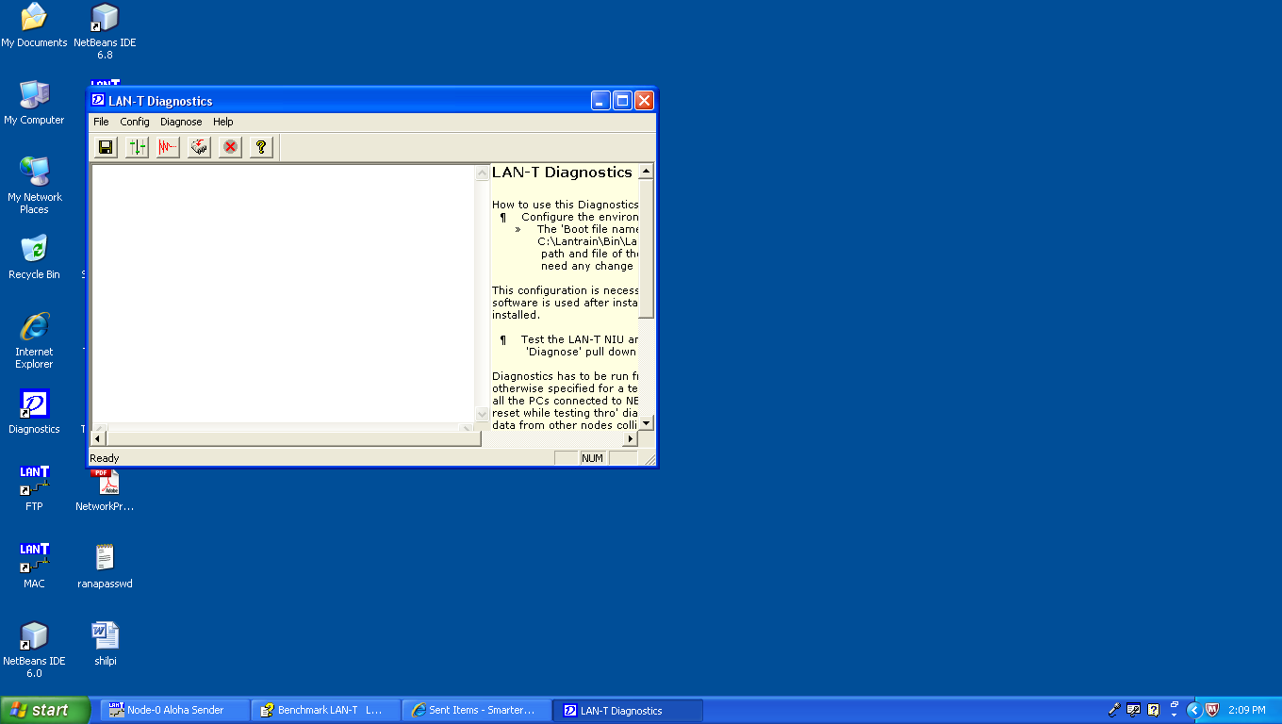
Fig 1:Interface of LAN TKIT

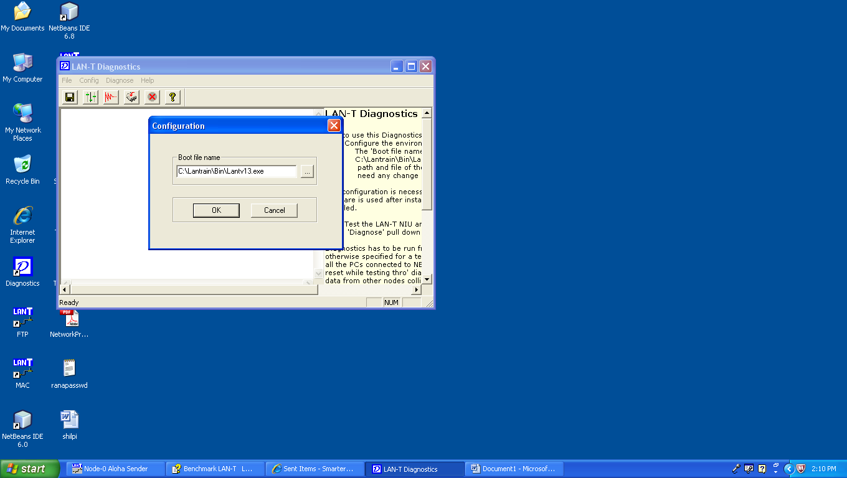
Fig 2: Configuration Interface of LAN TKIT

System Requirements & Packing List

System Requirements

PC : | Pentium II or higher  One PCI slot (32-bit) required.  (For Star related experiments that may be  developed by user, 2 slots are required in one of the PCs)  Minimum RAM as recommended by OS or by VC++ if installed
Operating System : | Windows 98 2nd Edition, Windows 2000 Professional
Number of PCs : | 2 – 3
VC++ compiler : | Version 6.0 or above  (Optional – for programming/modifying experiments, to do suggested exercises etc.,)

Packing List

Description | Qty
Network Emulator Unit (NEU) | 1 No
Network Interface Unit (NIU) | 3 Nos
LAN-T Power Supply (LAN-T PS) | 1 No
5-pin DIN cable (# 9915001) | 1 No
NIU-NEU Interface cable (# 9915002)  (D37 – D37 flat cable) | 3 Nos
Patch chords (# 9915003) | 1 Set
Manuals  (Installation manual, Programmer’s manual,  User manual) | 1 Set
Software CD | 1 No

The LAN-T CD contains self-installable software. It also contains device driver files for the NIU card that required while installing them. A setup screen appears when the CD is inserted in the CD ROM drive. Follow the instructions and complete the installation. If the setup screen does not appear, try one of the following:
1) Double click “My Computer” icon in the desktop and double click on the CD drive icon.
2) Type “D:\Setup” in the Run command. Substitute the actual CD drive letter in place of D.

The installation drive and path is defined to be C:\Lantrain by default. Leave this as such and proceed with the installation.
This installation creates Lantrain directory under C drive and copies all the software and necessary DLLs. It also creates LAN-T folder and shortcuts under Start-Programs menu and on the desktop.
The Lantrain directory contains all of the sub-directories and the files as given in the user manual (Introduction chapter). The BIN sub-directory contains some of the executable experiments that can be used to start those experiments. All other sub-directories and files are used while using with VC++.
The complete installation will take about 140MB of hard disk space. This includes the intermediate files generated by VC++ in “Debug” directory under each project (experiment). These intermediate files are created while compiling the source code in VC++. If the VC++ is not used then these intermediate files may be removed to save hard disk space.
Following experiment and diagnostics shortcuts are created on the desktop for easy accessing after installation:
- PKT
- MAC
- Token Bus
- Token Ring
- Stop Wait
- Sliding Window
- FTP
- Diagnostics
Softcopy of LAN-T manual in CHM format is available under the Start-Programs-LAN-T menu. All the LAN-T manuals are given here.

NIU card Installation
One 32-bit PCI slot is required in the PC to install each NIU card. Switch off the PC and plug-in the NIU card in a free PCI slot.
Connect one end of the NIU-NEU interface cable (Part# 9915002) to the NIU card. The other end has to be connected to the NEU either at “Node1 & 2” or “Node 2 & 3” or “Node 3 & 4” connector (at the rear of the NEU)
Switch on the PC. It will detect the card automatically and initiates driver installation wizard. Follow the steps and complete the installation. LAN-T CD contains the NIU device driver files. Keep this CD in the CR-ROM drive while installing the driver. Following are the steps that the wizard passes through and the recommended selections to install NIU successfully:
Step 1: The system detects the NIU PCI card as PCI Bridge. Click "Next".
Step 2: Select the Option "Search for the best driver for your device (recommended)" and click "Next".
Step 3: select CD-ROM check box and click "Next". Wizard will look for the *.inf file and the driver files in the LAN-T CD
Step 4: "Benchmark LANT_NIU: Device Driver" will be displayed along with the location of the INF file. Click "Next".
Step 5: Click "Finish" to complete the device driver installation.
After installing the software as given in chapter 2, run “Activate NIU” from the LAN-T program folder created under the Start-Program menu. This activates the NIU by adding and registering the driver files to the list of drivers that Windows 98 or Windows 2000 loads when it starts. Reboot the system when this program prompts to do so.
Install other NIUs in other PCs and connect to the NEU as said above.

NEU Installation
- Connect the power supply to the NEU using the 5-pin DIN cable (part# 9915001) provided with the Trainer. Connect the power supply to the AC outlet using a standard power cord. LAN-T power supply has an IEC type power socket for AC input and accepts universal supply voltages. Switch on the power supply.

2. Connect the NIUs to the NEU through the NIU-NEU flat Interface cable (part# 9915002).

3. Switch on the power to the NEU. The switch is at the rear panel of NEU.
LEDs will glow as follows:
Data Rate = 8Kbps
Topology = BUS
BER = 0
FER = 0
Delay = 0 bit
This is the default NEU condition while power-on or while reset.
  - To Emulate BUS/RING/STAR topology, press the Topology switch until the corresponding LED glows. During Power-on, the NEU emulates BUS topology.

5. To introduce Bit Errors, press the BER switch until the corresponding LED glows.
Similarly press
- FER switch to introduce Frame errors,
- Delay switch to introduce bit delays (0 to 15 bits) between the nodes and
- Data Rate switch to set the data rate between 8Kbps and 1Mbps.
Bit errors and Frame errors are introduced between nodes 2 & 3 only. Delay can be introduced between the nodes and it depends on how the nodes are interconnected.
6. Use patch cords (part# 9915003) to interconnect various elements like nodes, delay blocks, error generating blocks etc., in the NEU. Each node (with transceiver) in NEU has an Input, an Output, a Tx port and Rx port. Each delay has an input and output port.
Patch cord connections to setup a BUS network:
To connect nodes to the medium (BUS):
Connect posts N1 to T11, N2 – T21, N3 – T31, N4 – T41, N5 – T51, N6 – T61
To connect node output to its next delay input:
Connect posts T13 – D11, T23 – D21, T33 – D31, T43 – D41, T53 – D51, T63 – D61
To connect delay output to the its next node input:
Connect posts D12 – T22, D22 – T32, D32 – T42, D42 – T52, D52 – T62

Patch cord connections to setup a RING network:
Connect posts to emulate BUS network. Connect D62 – T12. This closes the loop and forms a Ring network.
Patch cord connections to setup a STAR network:
To connect nodes to the medium (BUS):
Connect posts N1 to T11, N2 – T21, N3 – T31, N4 – T41, N5 – T51, N6 – T61
To connect node output to its next delay input:
Connect posts T13 – D11, T23 – D21, T33 – D31, T43 – D41, T53 – D51, T63 – D61
To connect delay output to the Star master:
Connect posts D12 – S1, D22 – S2, D32 – S3, D42 – S4
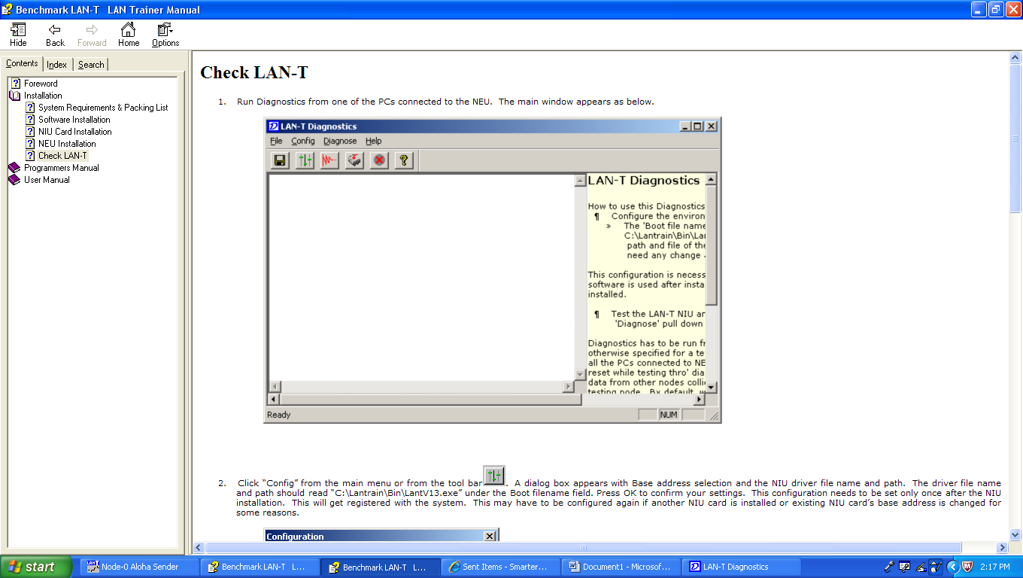
Fig 3:Check LAN TKIT

Introduction

The Benchmark LAN-T LAN Trainer consists of a Network Emulator Unit (NEU), PC Plug-in Network Interface Units (NIU) and Win95 based experiment software. The software contains a series of experiments in the form of stand-alone applications; ‘C’ source code for the experiments, and a NIU Library.
The NEU emulates 6 nodes, which can be configured to Bus, Ring or Star topologies. It also has error generators and delay generators between nodes.
Each NIU card emulates two independent network nodes supporting various MAC layers, on a single PC.
The NIU library provides a programming interface similar to that provided by typical Ethernet and other network adapters. This is register based, with command, data and status registers. These can be accessed via a set of C functions: NIU_Data(), NIU_Statistics etc.,

Frame Format
The format of the data frames used in the LAN-T is shown in Figure 1.1
1 Byte | 1 Byte | 0-998 Bytes | 2 Bytes | 2 Bytes
DA | SA | DATA | Checksum | Delimiter

Figure 4: LAN Trainer Frame Format
DA Destination Address
SA Source Address
DATA Data portion can be from 0 - 998 bytes
Checksum Checksum field is generated internally by the NIU library. The Library interface will generate the checksum while transmission, and also strip the checksum on reception. As far as the student is concerned this field is insignificant.
Delimiter Used internally for detecting the end of frame.

Guide to the LAN Trainer
To successfully use the LAN Trainer, a number of hardware and software components must be properly used together (see Fig. 1.1). Each PC acts as two nodes in the network. Both are connected to the Network Emulator Unit via the same cable. Thus, with 3 PCs, you can experiment with a 6-node network. On the software side, the screen is divided into 2 windows, one for each node. This is accomplished using the LAN Trainer control panel running under Windows - 95
.NIU Card
Each PC that is part of the LAN Trainer setup must have an NIU Card plugged into it. This card has two independent full-duplex serial channels each of which can operate at data rates between 8 Kb/s and 1 Mb/s. The card supports DMA as well as programmed I/O data transfers. With one such card, a PC acts as two independent network nodes.
Once it is properly installed, the Serial Card should not require further attention. The data rate is set from the Network Emulator Unit, and all other parameters can be set by software.

Network Emulator Unit
The Network Emulator Unit acts as a network interconnecting upto 6 network nodes (3 NIU Cards in 3 PCs). Each card is connected to the Network Emulator Unit via a cable with DB-37 connectors. Once properly installed, these should not normally be disturbed. The Network Emulator Unit has a number of jumpers that must be properly wired-up depending on the type of network one wants - a bus, a ring, or a star. This must correspond to the setting of the Topology selector switch. The Network Emulator Unit also has selector switches for Data Rate, Bit Delay, Error Rate and Frame Error Rate. These should be set in accordance with the instructions of each experiment. In addition, there is a Reset switch which should be used before every experiment, and in case of trouble.

NIU Library
Above the hardware is a library of C functions that provides a programming interface to the LAN Trainer, similar to that provided by typical Ethernet and other network adapters. This emulated NIU is register-based, with command, data and status registers. These can be accessed via a set of C functions: NIU_Cmd(), NIU_Data() and NIU_Status(). The NIU library also provides a comprehensive set of interrupts.

Application Software
The final component in any experiment is the application software. This uses the facilities of the NIU library to accomplish some communication task, such as transferring a message from one node to another. Each of the two nodes on each PC can have its independent application software. Your programs will be at this level.

The Physical Links
The simplest network connecting two computers A and B is an electrical link directly from one to the other. Each computer has a network interface unit (NIU) with a transmitter and a receiver. A packet is transmitted by one computer as a sequence of bits and received by the other in the same order. Depending on the time it takes to transmit one bit, the link has a capacity or bandwidth of C b/s (bits per second).
We can extend this network to accommodate a third computer, C, by adding a second NIU in each computer and two more links (Fig. 2.4 b). Each computer can send a packet to either of the others at any time by transmitting it on the appropriate link. This type of interconnection, referred to as a complete mesh topology, can be extended to connect N computers. Every computer must have (N-1) NIUs and the total number of links is N(N-1)/2 (Fig. 2.5 a). Thus, the benefit of never having to wait to transmit is outweighed by the large number of NIUs and links except when the number of computers, N, is small, say 3 or 4.
To reduce the number of links, every node is connected to one central node in the star topology (Fig. 2.5 b). A packet between any two nodes may need two hops via the central node. If the central node is the source or the destination, only one hop is required. The central node is a single point whose failure renders the entire network inoperative. In cases where most communication is between one server and its clients, the star topology is especially useful.
The single point of failure can be avoided by using the ring or bus topology (Fig. 2.5 c and d). In the ring, every computer is attached to a circular cable. As a packet circulates around the ring, it can be received by every node. To avoid the packet circulating indefinitely, it is removed by the transmitting node after one round. In order to handle these functions, the attachment is via an electronic circuit called a transceiver. The transceiver is a complex device and may fail unless carefully designed.
In the bus topology, the network is a single cable, with no active devices. Each node is connected to it via a simple tap. This can be very reliable and inexpensive. Owing to its simplicity and reliability, the bus is the most popular topology for local area networks. Ethernet, the most widely used LAN uses the bus topology.
Like the ring, the bus also has the broadcast property, i.e., as a packet propagates down the bus to its ends it can be received by every node. In the mesh and star topologies, sending the same packet to every node requires that N-1 copies of the packet be separately transmitted.

Making Sense
A network allows one computer to send electrical signals to another computer. These signals have to be somehow interpreted as a stream of bits. The stream of bits has different meanings depending on the application. If one computer sends a binary file, and the other expects to receive an e-mail message, clearly proper communication will not take place. This is analogous to a Central Government official speaking in Hindi to a villager who knows only Tamil.
In order for communication to take place, both parties, be they human or computer, must agree on a set of conventions such as what signals constitute a 1 and a 0, where are the byte-boundaries in a stream of bits, how is a binary file differentiated from an e-mail message. Such a set of conventions is a protocol.
A network may include computers manufactured by different vendors with software from various sources. For these to be able to communicate, the protocols used must be agreed upon by all the manufacturers, i.e., standards are required. For example, RS-232C is a standard protocol for transmission of a stream of bytes that is widely used for sending data between computers and peripherals such as printers and modems. TCP is a standard protocol used for reliable transmission of arbitrary data between computers in the Internet.

EXPERIMENT NO.-12
To implement a routing protocol and check its connectivity in a variable length subnet masked network
Objective: To be able to implement RIP(Routing Information Protocol) in the VLSM(Variable Length Subnet Masking) network so as to know about subnetting and dynamic configuration protocol and implement it in a real time scenario.
Software used:
CISCO Packet Tracer
Version 5.3.0.0088
Topology:
4 Routers connecting different networks connected through serial cables
3 End devices (P.C) or workstations to check the connectivity between different networks.

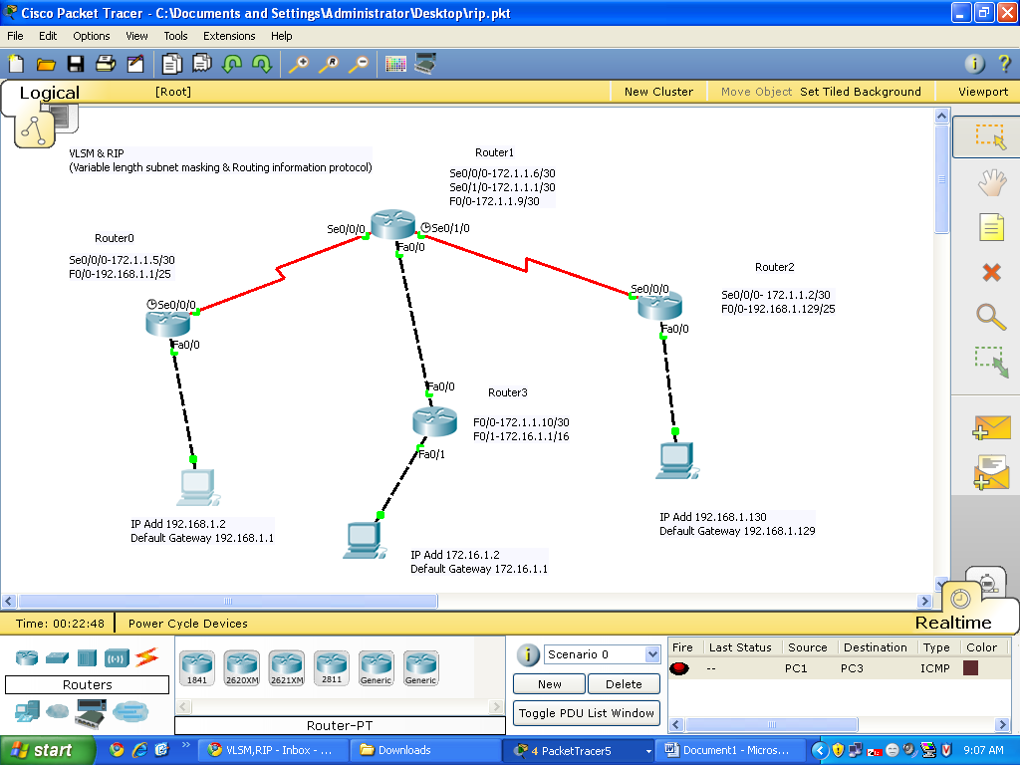
Fig 5:Packet Tracer

Router0: Se0/0/0-172.1.1.5/30 Router1: Se0/0/0-172.1.1.6/30
F0/0-192.168.1.1/25 Se0/1/0-172.1.1.1/30
F0/0-172.1.1.9/30
Router2: Se0/0/0- 172.1.1.2/30 Router3: F0/0-172.1.1.10/30
F0/0-192.168.1.129/25 F0/1-172.16.1.1/16
PC1: IP Add 192.168.1.2
Default Gateway 192.168.1.1
PC2: IP Add 172.16.1.2
Default Gateway 172.16.1.1
PC3: IP Add 192.168.1.130
Default Gateway 192.168.1.129
Theory & Implementation on the above taken Topology
IP Address: An IP address consists of 32 bits of information. These bits are divided into four sections, referred to as octets or bytes, each containing 1 byte (8 bits). You can depict an IP address using one of three methods:
Dotted-decimal, as in 172.16.30.56
Binary, as in 10101100.00010000.00011110.00111000
Hexadecimal, as in AC.10.1E.38
Summary of the three classes of networks
8 bits 8 bits 8 bits 8 bits
Class A: Network Host Host Host
Class B: Network Network Host Host
Class C: Network Network Network Host
Class D: Multicast
Class E: Reserved for future
Classfull IP address
Is divided into 5 major groups
- Class A
- Class B
- Class C
- Class D
- Class E
Class A, B and C are used in networking
Class D is used for broadcasting
Class E is reserved for the future
The following table shows the range of IPv4 addresses for all classfull type
Class A (0-127).(0-255).(0-255).(0-255)
Class B (128-191).(0-255).(0-255).(0-255)
Class C (192-223).(0-255).(0-255).(0-255)
Class D (224-239).(0-255).(0-255).(0-255)
Class E (240-255).(0-255).(0-255).(0-255)
Note : 127.0.0.0 is reserved for loopback testing.

IMPORTANT NOTE: Subnetting :Subnetting is essentially the modification of a single IP network to create two or more logically visible sub-sections. It entails changing the subnet mask of the local network number to produce an even number of smaller network numbers, each with a corresponding range of IP addresses.
Subnetting is required when one network number needs to be distributed across multiple LAN segments. This may be the case in instances when:
- Two network segments are restricted by distance limitations (for example, remote offices linked via point-to-point circuit).
- Segments need to be localized for network management reasons (accounting segment, sales segment, etc.).
- Hosts which dominate most of the LAN bandwidth need to be isolated.

RIP (Routing Information Protocol)
The key characteristics of RIP include the following:
-  RIP is a distance vector routing protocol.
-  Hop count is used as the metric for path selection.
-  The maximum allowable hop count is 15.
-  Routing updates are broadcast every 30 seconds by default.
-  RIP is capable of load-balancing over as many as sixteen equal-cost paths. (Four paths is the default.)
To enable a dynamic routing protocol, you must complete the following steps:
Step 1 Select a routing protocol: RIP, EIGRP, or OSPF.
Step 2 Assign IP network numbers without specifying subnet values (except for OSPF).
IMPORTANT NOTE: You must also assign network or subnet addresses and the appropriate subnet mask to the interfaces.
RIP Configuration
The router rip command selects RIP as the routing protocol.
© 2007 Cisco Systems, Inc. All rights reserved. ICND1 v1.0—5-13
RouterX(config)# router rip
Starts the RIP routing process

RouterX(config-router)# version 2
Enables RIP version 2

RouterX(config-router)# network network-number
Selects participating attached networks
Requires a major classful network number

The network command assigns a major network number that the router is directly connected
to. The RIP routing process associates interface addresses with the advertised network number
and will begin RIP packet processing on the specified interfaces.
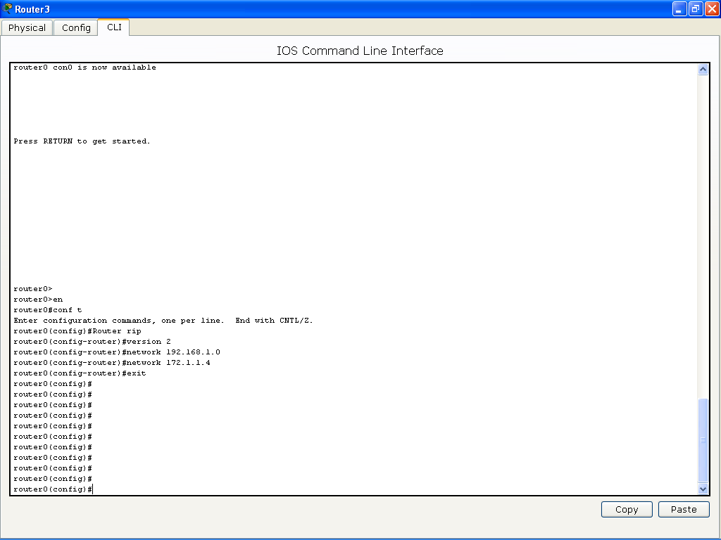
Fig 6:Interface
Verifying the RIP Configuration
The show ip protocols command displays values about routing protocols and the routing
protocol timer information that is associated with the router.
The table describes the significant fields shown in the display.
Field Description
Routing Protocol is "rip" Specifies the routing protocol used

Sending updates every 30 Specifies the time between sending updates
seconds

next due in 6 seconds Specifies when the next update is due to be sent

Invalid after 180 seconds Specifies the value of the invalid parameter

hold down 180 Specifies the current value of the hold-down parameter
flushed after 240 Specifies the time (in seconds) after which the individual routing information will be thrown (flushed) out

Outgoing update Specifies whether the outgoing filtering list has been set

Incoming update Specifies whether the incoming filtering list has been set

Redistributing Lists the protocol that is being redistributed

Default version control Specifies the version of RIP packets that are sent and received

Routing Specifies the networks for which the routing process is currently injecting routes

Routing Information Sources Lists all the routing sources that the Cisco IOS Software is using to build its routing table. For each source, you will see the following displayed:
■ IP address
■ Administrative distance
■ Time the last update was received from this source

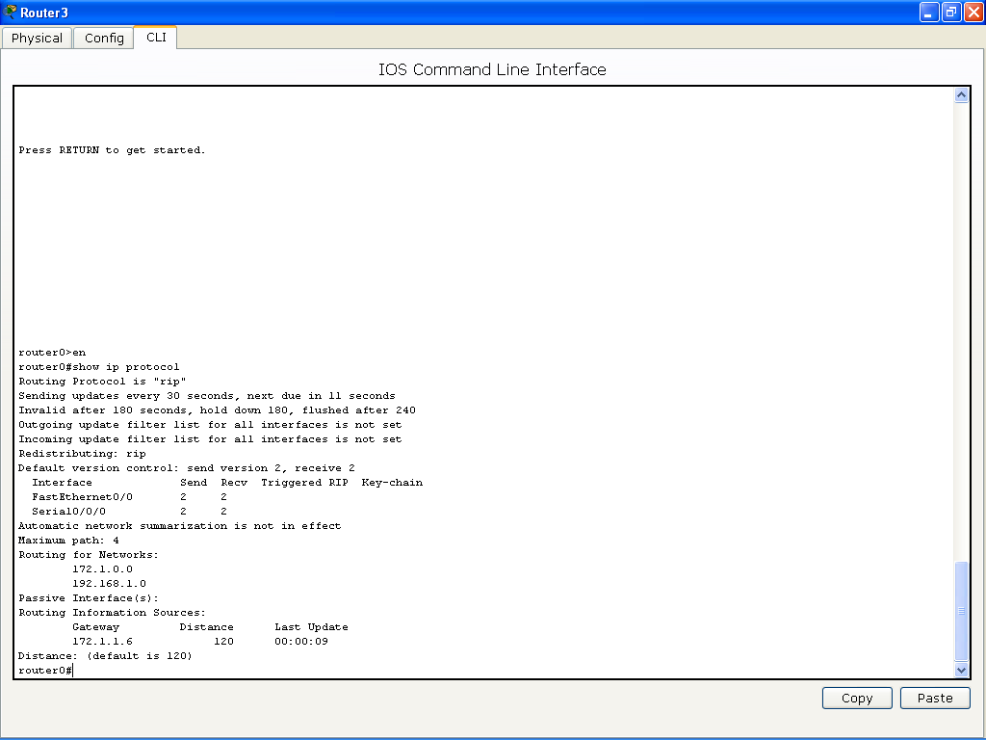
Fig 7:Interface
Displaying the IP Routing Table
The show ip route command displays the contents of the IP routing table.
The routing table contains entries for all known networks and subnetworks, and a code that
indicates how that information was learned. The output and function of key fields from the
show ip route command are explained in the table.
Output Description
R or C Identifies the source of the route. For example, a “C” indicates that the route came from a direct connection of the route to a router interface. An “R” indicates that RIP is the protocol that determined the route.

192.1.1.0 Indicates the address of the remote network.
172.1.1.8
192.168.1.128
120/1 The first number in the brackets is the administrative distance of the information source; the second number is the metric for the route (here, 1 hop).

via 10.1.1.2 Specifies the address of the next-hop router to the remote network.

00:00:07 Specifies the amount of time since the route was updated (here, 7 seconds).

Serial0/0/2 Specifies the interface through which the specified network can be reached.

If routing information is not being exchanged (that is, if the output of the show ip route
command shows no entries that were learned from a routing protocol), use the show runningconfig
or show ip protocols privileged EXEC commands on the router to check for a possible
misconfigured routing protocol.
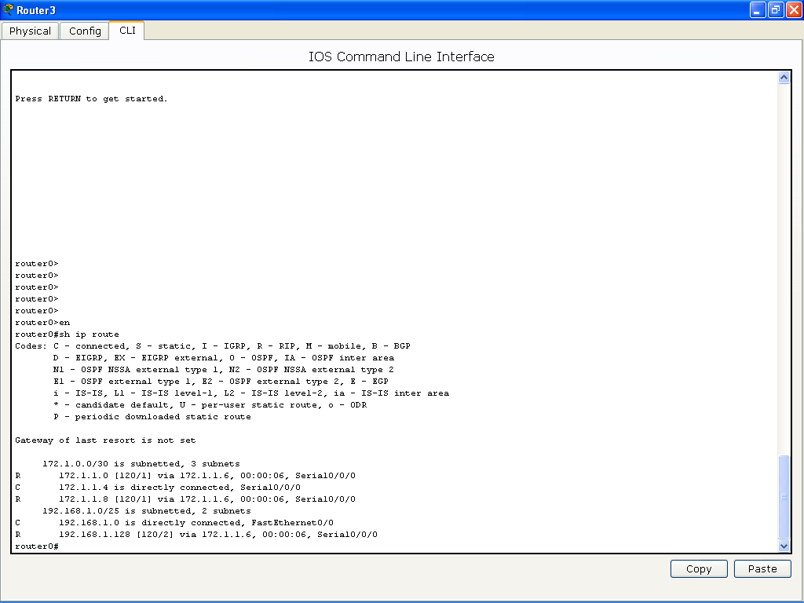
RIP Configuration Troubleshooting
Use the debug ip rip command to display RIP routing updates as they are sent and received.
The no debug all command turns off all debugging.
The following output indicates the source address from which updates were received:
RIP: received v1 update from 10.1.1.2 on Serial0/0/2
The following output indicates the destination addresses to which updates were sent:
RIP: sending v1 update to 255.255.255.255 via FastEthernet0/0
(172.16.1.1)
RIP: sending v1 update to 255.255.255.255 via Serial0/0/2
(10.1.1.1)

